NSCB Safeguarding Audit Tool 2017
Guidance for Completing the Audit

- Introduction
Thank you for taking the time to complete the Northamptonshire Safeguarding Children Board (NSCB) self-assessment audit on behalf of your School.

The NSCB carries out audits to monitor the effectiveness of schools’ arrangements to safeguard children across Northamptonshire and Working Together 2015 provides the NSCB with a clear framework to enable this monitoring. The findings from the self-assessment will enhance the NSCB’s understanding of schools’ safeguarding processes by identifying effective safeguarding practice and areas for improvement.

The deadline for submission of all returns is Friday 7th July 2017 and please submit electronic copies only.

Please find attached the following:

- A copy of the self-assessment audit tool and guidance for completing the audit tool.

Please ensure your supporting evidence is referenced by providing details of the document and where it is stored, but DO NOT submit, attach or embed documents into the template unless requested by the NSCB.

The attached guidance is to assist schools in completing the Self-Assessment. Once you have read this guidance, if you still have questions on completing the self-assessment do not hesitate to contact:

Kevin Johnson – Project Officer
Email: NSCB@Northamptonshire.gov.uk Tel: 01604 364036

- What is the Schools Audit?
Safeguarding children is everyone’s responsibility. The legislation that governs this audit as detailed below, places a duty on all schools to ensure their functions are discharged with regard to the need to safeguard and promote the welfare of children.

Working Together 2015 or the NSCB do not give organisations any new or additional functions, nor does it override their existing functions. Rather, it seeks to ensure that, when schools go about their day to day business, they do so in a way that takes into account the need to safeguard and promote the welfare of children. In practice, this means that schools need to have in place safe systems and processes. An example of this is ensuring that staff are trained in safeguarding, in policies and procedures, that safe recruitment processes are in place, and that any commissioning arrangements include a requirement to safeguard children.

- Who does the Audit Apply to? (Working Together 2015 Chapter 2, paragraph 10, page 55)
The governing bodies, management committees or proprietors of the following schools have duties in relation to safeguarding and promoting the welfare of pupils:

- Maintained schools (including maintained nursery schools), further education colleges and sixth form colleges, and pupil referral units;
- Independent schools (including academy schools, free schools and alternative provision academies); and
- Non maintained special schools

- How do we know if it is Being Implemented Properly?
Working Together to Safeguard Children (2015) requires Local Safeguarding Children Boards to assess whether "LSCB Partners are fulfilling their statutory obligations." To ensure that this is happening, Northamptonshire Safeguarding Children Board undertakes an audit that looks at schools’ compliance. This is undertaken every two years by way of a single agency self-assessment. Each school is asked to complete the self-assessment and provide evidence of how they comply with the audit when carrying out their day to day business. This audit will give an indication of how well schools are working to keep children safe. Where a school has not fully met the standards they will be asked to produce an action plan to address any areas of development identified.

- Guidance Notes to Support the Completion of the Self-Assessment Tool
This assessment tool has been designed to provide schools with the opportunity to highlight areas of strength and to identify areas for development in respect of their S.175 duties and responsibilities. This will assist the LSCB partnership in identifying where to target support in order to drive forwards safeguarding standards.

- Completing the Assessment Tool
- If a school decides that a particular strand within the assessment tool is not applicable they must clearly set out why the standard is not relevant and the possible alternative.
- When referring to children, the standard includes all children and young people aged 0 to 18 years.
- Safeguarding and promoting the welfare of children is defined within Working Together to Safeguard Children 2015 as:

- Protecting children from maltreatment.
- Preventing impairment of children’s health or development.
- Ensuring that children are growing up in circumstances consistent with the provision of safe and effective care and taking care to enable all children to have the best outcomes.

This tool covers the continuum of safeguarding need from early safeguarding provision to statutory child protection processes.

- Grade Descriptors
Guidance on how you grade the standards is contained within the grade descriptors.

The traffic light system indicates how a school considers itself against achieving the minimum standard, whilst identifying any areas for improvement if applicable.

If your school assesses itself, as Not Met (red) or Partly Met (amber), areas for development need to be recorded along with a timescale for completion.

Fully Met (green) All areas exceed the minimum requirements and indicate innovative and exceptional practice

Partly Met (amber) Most areas meet the minimum requirements, but there are areas for improvement or review

Not Met (red) Areas assessed are below the minimum requirements with immediate action necessary

N/A (grey) This indicator is not applicable to your school. If you grade the statement as not applicable, please ensure that you provide evidence as to why you consider it not to be applicable to your school.

- Evidencing the Standards
When completing the audit tool and grading your school against the standards, you must be sure that statements made within the completed tool are correct and based on accessible evidence.

This self-assessment tool does not require schools to submit documentation as evidence at this stage; however evidence may be requested later in the process.

The self-assessment must demonstrate the impact (the ‘so what’) of policies and practice on identifiable improved outcomes for children young people and families for which evidence is available.

- Demonstrating Outcomes
To demonstrate improved outcomes you may, for example, discuss how you identified areas requiring improvement, what you hoped to achieve, what you did and then set out who was better off and why.

- Getting Started

- The audit is to be completed on the NSCB Section 175 Audit Tool – it is an Excel spreadsheet. The template is also attached to this email.

- When you open up the NSCB Section 175 Audit Tool, you will see there are different tabs on the bottom of the spreadsheet.

- Completing the Self-Assessment Audit

- The audit is divided into 9 standards, each with a separate worksheet. Please click on the ‘Introduction’ tab to see a breakdown of the 9 worksheets.

- Click on ‘User Details’ to fill in the key details for your school – school name, name of person completing the audit, completion date etc. The finalised audit should be signed off by the Head Teacher and Chair of Governors

- You can either navigate to the worksheets by clicking on the numbers ‘1’ to ‘9’ at the bottom of the spreadsheet or when the page has been fully completed you will have an option to move to the next section by clicking on the link at the bottom of the page.

- The following pages give examples of how to complete each worksheet.
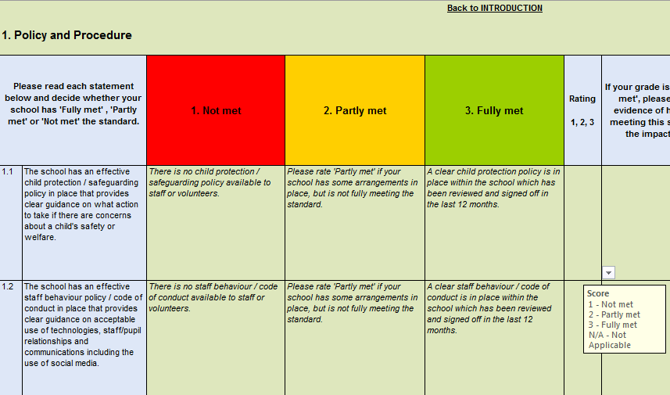
Click on the drop down box to RAG (Red, Amber, Green) rate your school’s score. If you change the decision, highlight the box and click ‘Delete’ to make it blank again.

This column provides an example of what constitutes not meeting the standard
Read each statement and think about whether your school is not meeting, partly meeting or fully meeting the standard
This column details what constitutes partly meeting the standard
This column provides an explanation of what constitutes fully meeting the standard.

- When you have graded your school against each statement, you will be required to provide evidence to support your grading:

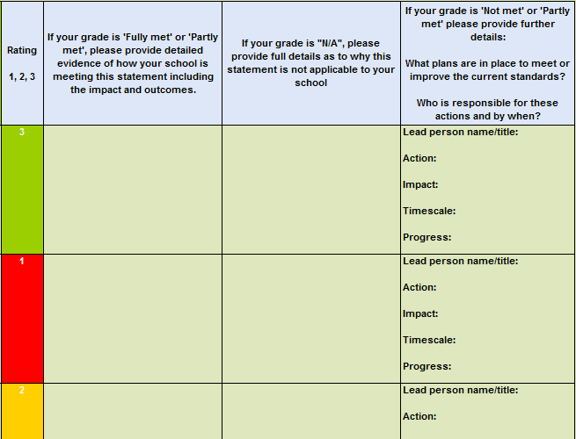
If, like this statement, you have graded the criteria as ‘fully met’, you will be required to evidence how your school is meeting this statement and score. Remember to answer the ‘so what?’ question.
If your grading is ‘not met or ‘partly met’ you will be required to provide details of how your school plans to make improvements, and provide evidence of these plans. You should identify:
- What plans will be put in place?
- Who will be the lead for these plans?
- How will impact be measured?
- What timescale has been put in place to monitor progress?

- Once you have completed the sheet, you will notice the box at the bottom will automatically change from ‘Remember to fill in the blanks’ to ‘Sheet Complete’. At this point you can either use the link below or tabs at the bottom of the sheet to move to the next section.
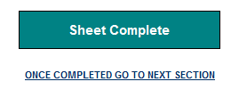
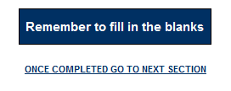

- Once you have completed the worksheets, the spreadsheet will automatically generate an overall School Action Plan from your responses. Click on the ‘Schools Action Plan Summary’ tab to view. The Action Plan Summary will look something like this depending the level of detail entered:

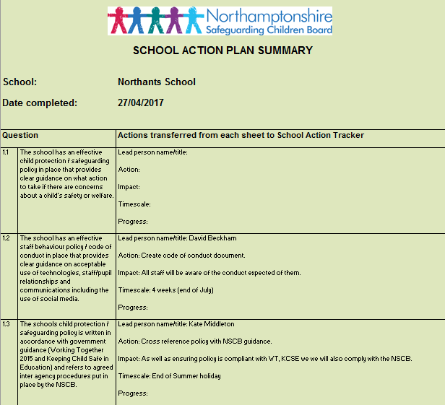
The spreadsheet will transfer all comments from the worksheets into these boxes, so you are able to look at and print your school’s actions in one place. Where you have marked a statement as completed, you will notice that no text has been transferred into these boxes. Before printing you may wish to hide these rows to minimise the number of pages that will be printed.

- The spreadsheet will also generate a score summary. Click on ‘Score Summary’ tab. The score summary will look like this:

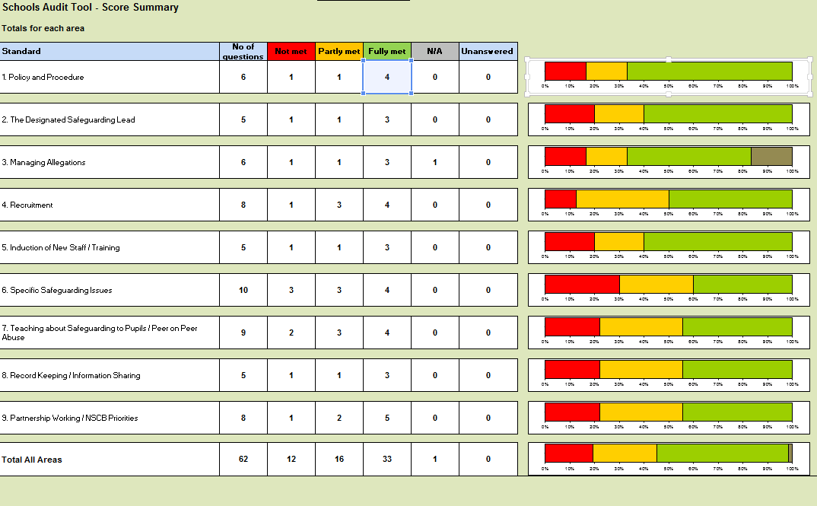
The score summary gives you a breakdown of how well your school is meeting the standards. By looking at the % you will be able to see your % for each standard as well as an overall standard. This will enable you to quickly identify standards that require urgent action.

- Once you have completed the audit you may want to print and save copies of both the Score Summary and Action Plan for your record.

- Now that you have finished the audit, please ensure it is signed off by the Head Teacher and Chair of Governors within your school and send the finalised electronic copy of the audit to nscb@northamptonshire.gcsx.gov.uk by Friday 7th July 2017 (please ensure the file name is the same as it was sent to you in. This will assist the Business Office in reporting and ensuring all schools have responded to the audit).

As established under The Further Education and Higher Education Act 1992.
Section 175, The Education Act 2002 – for management committees of pupil referral units, this is by virtue of regulation 3 paragraph 19A of schedule 1 to The Education (Pupil Referral Units) (Application of Enactments) (England) Regulations 2007.
Under The Education (Independent School Standards) (England) Regulations 2014.
Under The Education (Non-Maintained Special Schools) (England) Regulations 2011.

