Registering for Policy and Procedure Updates via NSCB Website

The NSCB website offers professionals and organisations the opportunity to receive alerts when updates to the policy and procedures manual are made. Below is a step by step guide on how to register for updates.

Step 1

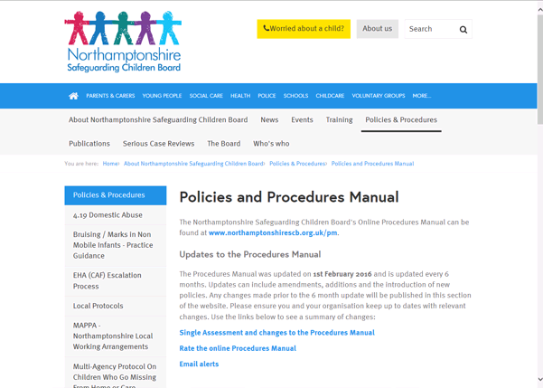
Click on the link to the Child Protection Procedures Manual.
Step 2
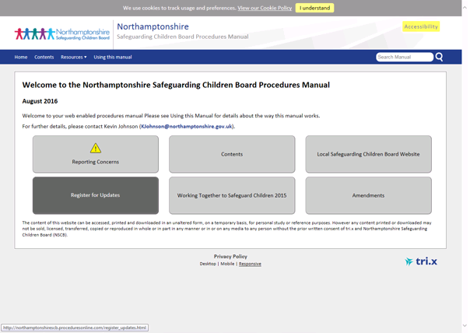
From the Child Protection Procedures Manual Homepage Click on the ‘Register for Alerts’ tab on the left hand side.

Step 3
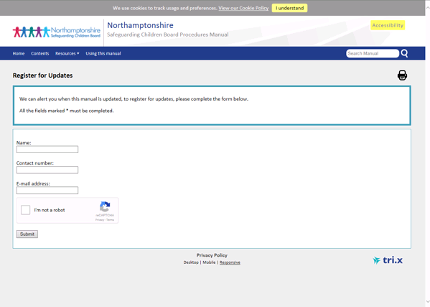
Complete the fields marked to register for alerts.
Once you have completed all of the fields you will see the below screen when you have registered for alerts.
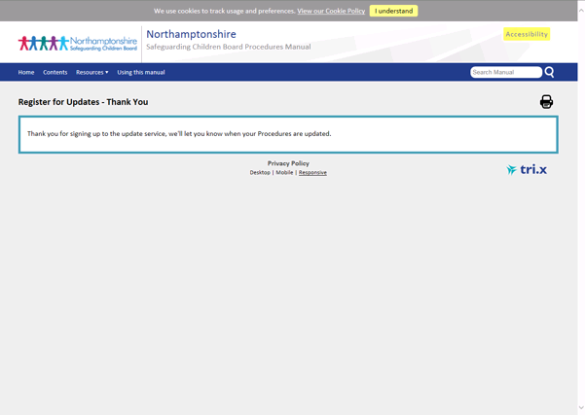
Anyone having difficulties registering for alerts via the website should contact the Business Office on 01604 364036 or nscb@northamptonshire.gov.uk

