Ten Steps to Get You Started with E-Learning
- In order to access free NSCP E-Learning you must register via the NSCP Website on the following link, if you use any other method, you may be charged for your training:
http://www.northamptonshirescb.org.uk/about-northamptonshire-safeguarding-children-partnership/training/e-learning/
- Select the link to register

Please ensure that you take time to read the information provided on the self-registration page before proceeding. If you require any further help, please contact the Business Office in the first instance on nscp@northamptonshire.gov.uk
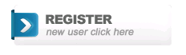
- When you are ready, please select the icon to continue

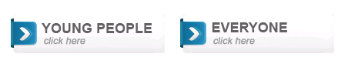
- If you are a young person aged between 11 -18, working as a youth volunteer, peer mentor or babysitter, please follow the left hand link on the next page.
If you are a member of an NSCP partner organisation, a voluntary / third sector worker or are a member of the Northamptonshire Children’s Workforce, please follow the right hand link.
If you are unsure whether you qualify for free training, please contact the Business Office on the email above before proceeding.
5. Registration
Select the options that best represent your organisation and department – please make sure that you read all options before making your selection

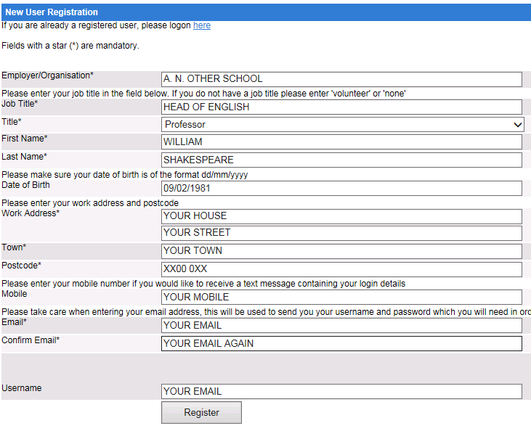
Complete your registration details.
All information submitted to the site is secure

6. For all registrations – now follow the instructions to log-in
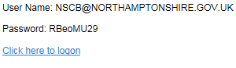

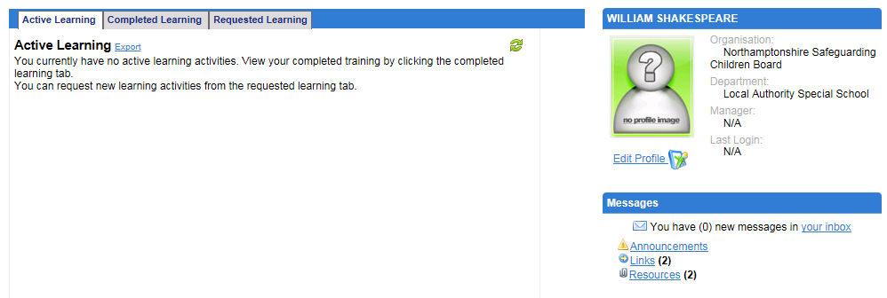

Welcome to your personal dashboard.
Any active courses will be displayed on this page. Now select the “Requested Learning Tab” to select your first course.

7. Select “Course Request” to access the Directory
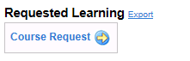

8. Select your preferred course (one at a time – don’t get carried away, remember that your four week completion time starts from this point)

9. Complete request process

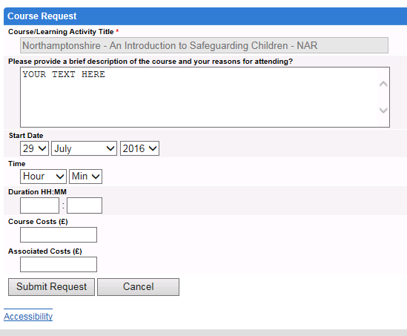
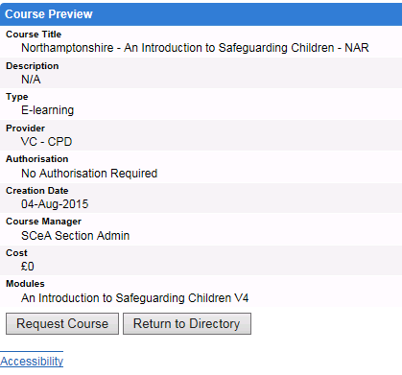

10. Return to your “Active Learning” tab, and you will find that your preferred course is now available
Happy Learning!
