Useful Information & Contact Details
Below you will find some essential details you might need and some useful phone numbers and details of relevant people / agencies while your child(ren) is in Police protection:
Date / time Police protection began:
…………………………………………………………………………………………………………………………………………………
Date / time Police protection will end (up to 72 hours from time commenced):
…………………………………………………………………………………………………………………………………………………
Police Contact Details:
Officer taking child(ren) into Police protection:
…………………………………………………………………………………………………………………………………………………
Police Designated Officer:
…………………………………………………………………………………………………………………………………………………
Contact Number:
…………………………………………………………………………………………………………………………………………………
Childrens Trust Details:
Social Worker:
…………………………………………………………………………………………………………………………………………………
Contact Number:


………………………………………………………………………………………………………………………………….



Police Protection -
Guide for Young People
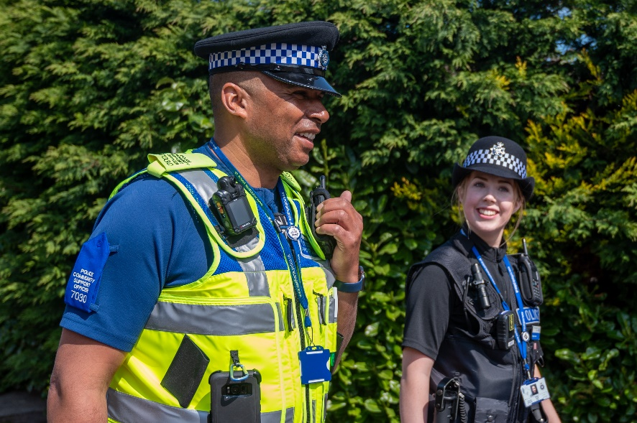

What is Police protection?
Police Protection is an emergency power under Section 46 Children Act (1989) which allows any Police Officer to protect a child who they reasonably believe to be at risk of significant harm.

Why am I in Police protection?
You have been placed into Police protection because a Police Officer has reasonable cause to believe you would be at risk of significant harm if you remained where you were or if someone tries to remove you.

How long does Police protection last?
Police Protection will last for no more than 72 hours (3 days).

What do the Police do?
The priority for Police is to see if you need any medical help. Following this, you will be taken to suitable accommodation. The officer will need to make a record of the following information:
- Your full details;
- Who has parental responsibility for you?
- The full reason for using Police protection;
- The time Police protection started (and the time it ends);
- Where you have been accommodated and
- Any discussion with other professionals or agencies.

The Police Officer also needs to:
- Inform a supervising officer, who will then become the Police Designated Officer for your case;
- Inform Northamptonshire Children’s Trust;
- Contact any other parents, and anyone with parental responsibility, or any other person you were living with immediately before being taken into Police protection;
- The Police Officer must tell you what is happening and the reasons why Police Protection is being used and what it means for you.

What does Northamptonshire Children’s Trust Do?
The Children’s Trust must provide suitable accommodation for all children taken into Police protection.

After being informed by Police that a child is in Police protection, the Children’s Trust will start safeguarding procedures. This includes having a Strategy Meeting with Police colleagues and any other relevant parties (e.g. health and education). A statutory assessment will be started which will look at next steps to be taken once 72 hours of Police protection have expired.

What part do I play in the process?
It is important that professionals always listen to and respond to your needs and views. Efforts must be made to keep you appropriately informed, explaining what has already happened, the reasons for this and what is going to happen next.

Can anyone see me while I’m in Police protection?
The Police Designated Officer must allow contact with certain people whilst you are in Police protection, provided it is reasonable and in your best interests.

Where will I go while in Police protection?
You need to be placed in ‘suitable accommodation’ - this can be local authority accommodation, such as children’s home or in foster care. You could also be placed with a suitable relative or other carer although, when considering a relative, a risk assessment must be conducted by Police and Children’s Social Care. Suitable accommodation can also mean staying in hospital, but a Police Station is not classed as suitable accommodation.

How does Police protection End?
Police protection will end in one of the following ways:
- 72 hours (3 days) passes;
- An Emergency Protection Order (EPO) or Interim Care Order (ICO) is obtained by the Children’s Trust or Police;
- You are provided with accommodation by the Children’s Trust under Section 20 and you are no longer considered to be at risk of significant harm;
- Police and the Children’s Trust agree that you are no longer at risk and can return home.

