- Introduction
Thank you for taking the time to complete the Northamptonshire Safeguarding Children Partnership (NSCP) self-assessment audit on behalf of your education setting.

The NSCP carries out audits to monitor the effectiveness of education settings’ arrangements to safeguard children across Northamptonshire and Working Together 2018 provides the NSCP with a clear framework to enable this monitoring. The findings from the self-assessment will enhance the NSCP’s understanding of education settings’ safeguarding processes by identifying effective safeguarding practice and areas for improvement.

The deadline for submission of all returns is 14 January 2022, however, should education settings complete the audit before this date we would welcome any early submissions. Please submit electronic copies only.

Please find attached the following:

- A copy of the self-assessment audit tool and guidance for completing the audit tool.
- An email from the NSCP explaining the audit process

Please ensure your supporting evidence is referenced by providing details of the document and where it is stored, but DO NOT submit, attach or embed documents into the template unless requested by the NSCP.

The attached guidance is to assist education settings in completing the Self-Assessment. Once you have read this guidance, if you still have questions on completing the self-assessment do not hesitate to contact:

Kevin Johnson – Project Officer
Email: NSCP@northnorthants.gov.uk Tel: 07872 148334

- What is the Education settings Audit?
Safeguarding children is everyone’s responsibility. The legislation that governs this audit as detailed below, places a duty on all education settings to ensure their functions are discharged with regard to the need to safeguard and promote the welfare of children.

Working Together 2018 or the NSCP do not give organisations any new or additional functions, nor does it override their existing functions. Rather, it seeks to ensure that, when education settings go about their day-to-day business, they do so in a way that takes into account the need to safeguard and promote the welfare of children. In practice, this means that education settings need to have in place safe systems and processes. An example of this is ensuring that staff are trained in safeguarding, in policies and procedures, that safe recruitment processes are in place, and that any commissioning arrangements include a requirement to safeguard children.

- Who does the Audit Apply to? (Working Together 2018 Chapter 2, paragraph 11, page 59)
The following have duties in relation to safeguarding and promoting the welfare of children:

- governing bodies of maintained education settings (including maintained nursery education settings), further education colleges and sixth-form colleges
- proprietors of academy education settings, free education settings, alternative provision academies and non-maintained special education settings. In the case of academies and free education settings trusts, the proprietor will be the trust itself
- proprietors of independent education settings
- management committees of pupil referral units.

This guidance applies in its entirety to all education settings.

Education settings, colleges, and other educational settings must also have regard to the statutory guidance Keeping Children Safe in Education 2021, which provides further guidance as to how they should fulfil their duties in respect of safeguarding and promoting the welfare of children in their care.

- Guidance Notes to Support the Completion of the Self-Assessment Tool
This assessment tool has been designed to provide education settings with the opportunity to highlight areas of strength and to identify areas for development in respect of their S.175 duties and responsibilities. This will assist the partnership in identifying where to target support to drive forwards safeguarding standards.

- Completing the Assessment Tool
- If an education setting decides that a particular strand within the assessment tool is not applicable, they must clearly set out why the standard is not relevant and the possible alternative.
- When referring to children, the standard includes all children and young people aged 0 to 18 years.
- Safeguarding and promoting the welfare of children is defined within Working Together to Safeguard Children 2018
This tool covers the continuum of safeguarding need from early safeguarding provision to statutory child protection processes.

- Grade Descriptors
Guidance on how you grade the standards is contained within the grade descriptors.

If your education setting assesses itself as Not Met or Partly Met, areas for development need to be recorded along with a timescale for completion.

Fully Met All areas exceed the minimum requirements and indicate innovative and exceptional practice

Partly Met Most areas meet the minimum requirements, but there are areas for improvement or review

Not Met Areas assessed are below the minimum requirements with immediate action necessary

N/A This indicator is not applicable to your education setting. If you grade the statement as not applicable, please ensure that you provide evidence as to why you consider it not to be applicable to your education setting.

- Evidencing the Standards

When completing the audit tool and grading your education setting against the standards, you must be sure that statements made within the completed tool are correct and based on accessible evidence.

This self-assessment tool does not require education settings to submit documentation as evidence at this stage; however evidence may be requested later in the process.

- Getting Started

- The audit is to be completed on the NSCP Section 175 Audit Tool – it is an Excel spreadsheet. The template is also attached to this email.

- When you open up the NSCP Section 175 Audit Tool, you will see there are different tabs on the bottom of the spreadsheet.

- Completing the Self-Assessment Audit

- The audit is divided into 10 standards, each with a separate worksheet. Please click on the ‘Introduction’ tab to see a breakdown of the 10 worksheets.

- Click on ‘User Details’ to fill in the key details for your education settings – education settings name, name of person completing the audit, completion date etc. The finalised audit should be signed off by the Head Teacher and Chair of Governors.

- You can either navigate to the worksheets by clicking on the numbers ‘1’ to ‘9’ at the bottom of the spreadsheet or when the page has been fully completed you will have an option to move to the next section by clicking on the link at the bottom of the page.

- The following pages give examples of how to complete each worksheet.

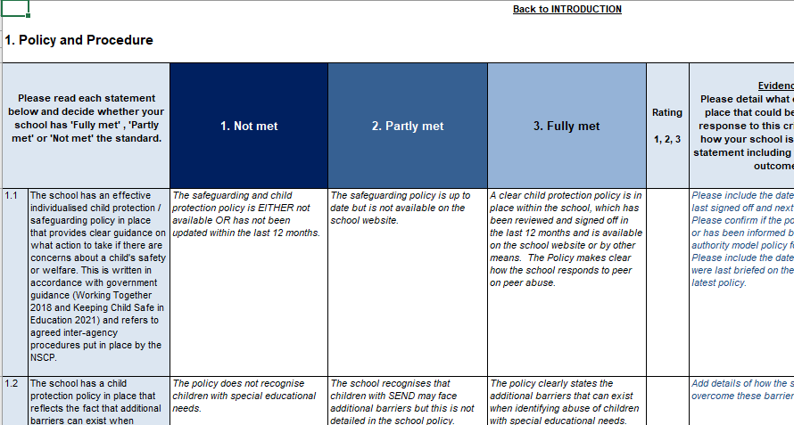

Read each statement and think about whether your education settings is not meeting, partly meeting or fully meeting the standard
This column provides an example of what constitutes not meeting the standard
This column details what constitutes partly meeting the standard
This column provides an explanation of what constitutes fully meeting the standard.
Click on the drop-down box to rate your education settings’s score. If you change the decision, highlight the box and click ‘Delete’ to make it blank again.

- When you have graded your education setting against each statement, you will be required to provide evidence to support your grading:

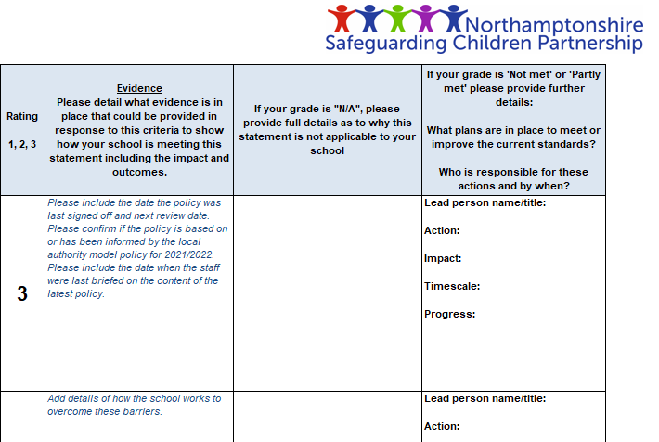
If, like this statement, you have graded the criteria as ‘fully met’, you will be required to evidence how your education settings is meeting this statement and score. Remember to answer the ‘so what?’ question.
If your grading is ‘not met or ‘partly met’ you will be required to provide details of how your education settings plans to make improvements, and provide evidence of these plans. You should identify:
- What plans will be put in place?
- Who will be the lead for these plans?
- How will impact be measured?
- What timescale has been put in place to monitor progress?

To ensure this text does not delete when you click on the box perform a double click and the headings will remain.

- Once you have completed the sheet, you will notice the box at the bottom will automatically change from ‘Remember to fill in the blanks’ to ‘Sheet Complete’. At this point you can either use the link below or tabs at the bottom of the sheet to move to the next section.
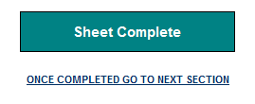
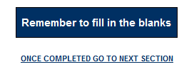

- Once you have completed the worksheets, the spreadsheet will automatically generate an overall Education setting Action Plan from your responses. Click on the ‘Education setting Action Plan Summary’ tab to view. The Action Plan Summary will look something like this depending the level of detail entered:

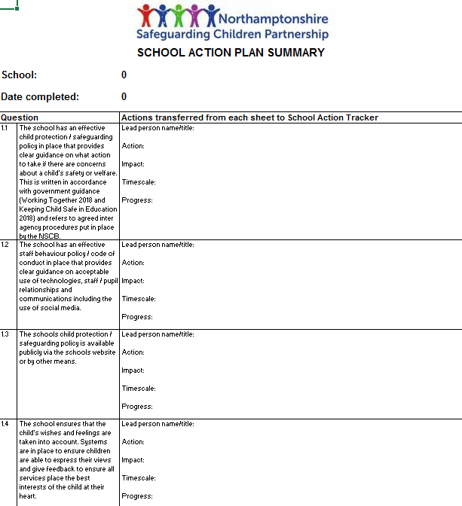
The spreadsheet will transfer all comments from the worksheets into these boxes, so you are able to look at and print your education settings’s actions in one place. Where you have marked a statement as completed, you will notice that no text has been transferred into these boxes. Before printing you may wish to hide these rows to minimise the number of pages that will be printed.

- The spreadsheet will also generate a score summary. Click on ‘Score Summary’ tab. The score summary will look like this:

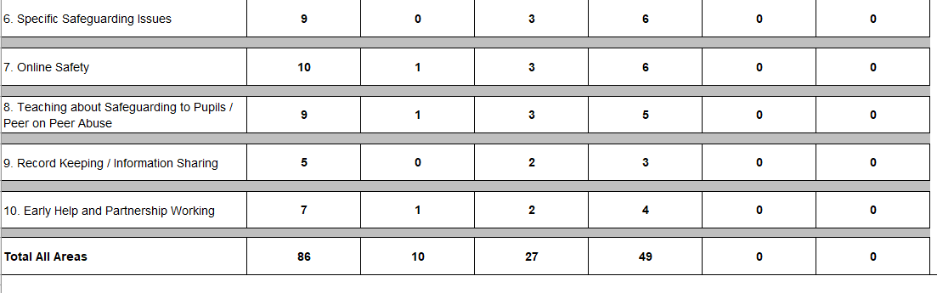
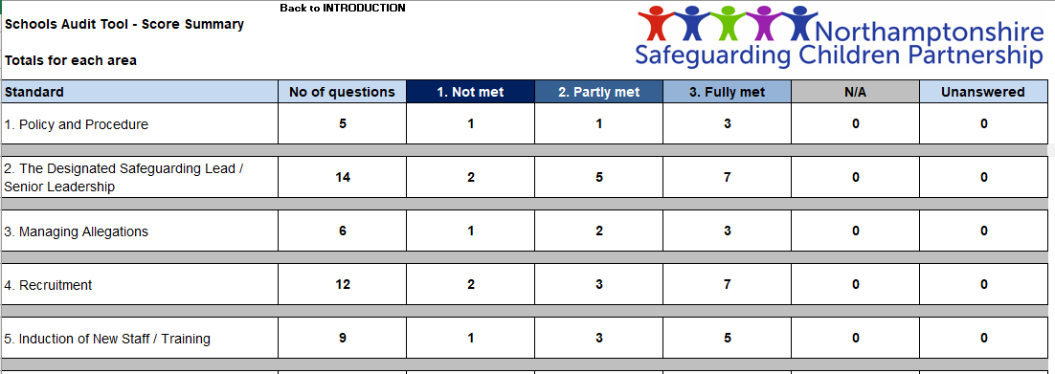

- Once you have completed the audit you may want to print and save copies of both the Score Summary and Action Plan for your record.

- Now that you have finished the audit, please ensure it is signed off by the Head Teacher and Chair of Governors within your education settings and send the finalised electronic copy of the audit to nscp@northnorthants.gov.uk by 14 January 2022.

Further education colleges and sixth-form colleges as established under the Further Education and Higher Education Act 1992 and institutions designated as being within the further education sector. It relates to their responsibilities towards children who are receiving education or training at the college.
Under the Education (Independent Education settings Standards) (England) Regulations 2014
Under the Education (Non-Maintained Special Education settings) (England) Regulations 2011
Section 175, Education Act 2002 for management committees of pupil referral units, this is by virtue of regulation 3 and paragraph 19A of Schedule 1 to the Education (Pupil Referral Units) (Application of Enactments) (England) Regulations 2007.
Keeping Children Safe in Education.

