
C
Case Study: Part One

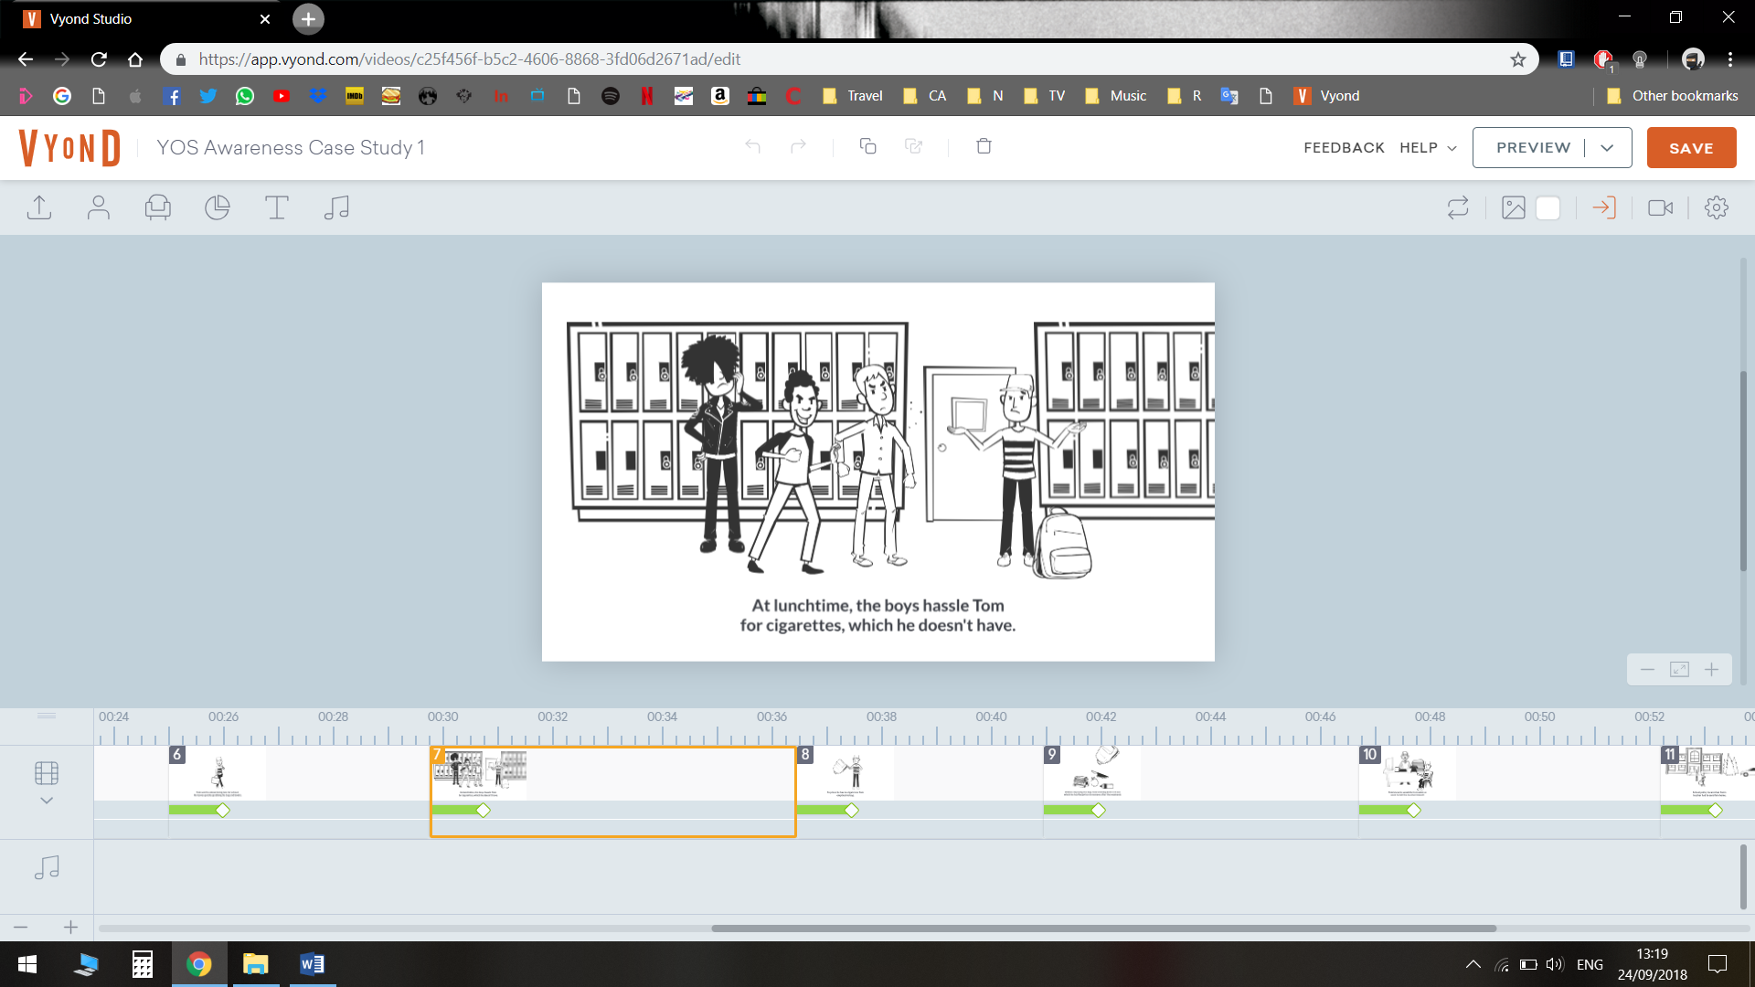
Tom is 15 years old. He attends mainstream school. His hobbies are fishing and working on motorbikes. Over the past few weeks Tom has been having some difficulties with a group of lads in school, they have made threats to hurt him. Tom is concerned about this but not enough to tell anyone about it.
One Monday morning Tom slept in for school and was rushing around to get all his things together. He picked up his bag and threw his books in before leaving to try to arrive on time.
During lunch time break, the lads Tom had been having some problems with started to goad him again. They said if he didn’t give them a fag he would get beaten up. Tom wanted to prove he did not have any fags so emptied his bag in front on them. On doing so a knife fell out, which had been in the bag from a fishing trip on the previous day. Tom knew he would be in trouble for having a knife on the school premises, so he went to tell the teacher before anyone else did.
School policy meant that the teacher had to report this to the police and Tom was sent home.
Case Study: Part Two

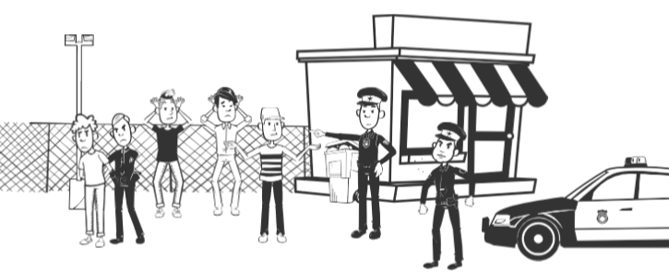
Tom has now moved into Year 11 and over the Summer he made some friends in the new neighbourhood he had moved into. Tom knew a lot of this friendship group had been in trouble with the police before, but he wasn't worried about this. They had all been good to him and had sorted the problems he was having before with the group of lads at school.
Tom was asked to hold on to some cannabis for one of the group and advised that it would be a good idea to carry a knife to keep himself and the drugs safe. Tom felt that he owed his friends this favour after them sorting out his troubles at school. He didn’t really consider the consequences of holding the cannabis. He also wasn’t too concerned about trouble from others because he believed the group would look out for him. From this point Tom always made sure he had a knife in his possession.
One evening the group were hanging around the local shops. The police attended as the shop owner had made complaints. The police proceeded to stop and search all of them due to ongoing issues in the area. On doing so they found Tom to be in possession of a knife. Tom was arrested.
Case Study: Part Three

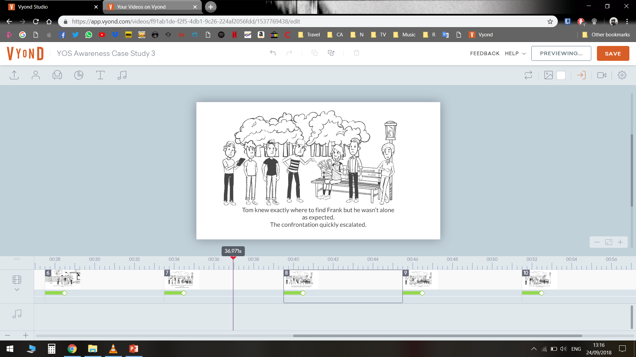
Tom worked with the Youth Offending Service following part 2 and completed the relevant learning interventions. Although he recognised the risks of carrying knives and the concerns about his friendship group he struggled to make any positive changes. Tom felt a loyalty to his friends and felt that if he tried to move away from them it would cause more trouble. Tom and his peers continued to sell cannabis in the local area.
A year later, on a Friday evening the group gathered as usual. Tom’s friend was owed £30 from Frank for cannabis. The group agreed that this couldn’t be ignored, they asked Tom and 3 others to go and find him to get the money owed.
Tom and his peers knew where Frank would be. They expected that when they approached him about it, he would simply hand over the money. This was not the case, Frank was with 2 others and the confrontation quickly escalated into a physical fight. Tom had reached into the waistband of his trousers and presented the knife to threaten them. On doing so Frank pushed Tom and he dropped the knife on the floor. In a struggle Tom picked the knife up and stabbed Frank in the stomach. Tom realising what he had done ran off leaving the Frank for dead. When Frank’s friends realised what had happened they called an ambulance and used his t-shirt to apply pressure to the wound.
VICTIM IMPACT CIRCLE

Use the circle to mark all the people that may be affected by Tom’s offence. The closer to the middle they are the more impact the offence had for them.

