How to register for online referrals to the Northamptonshire Multi-Agency Safeguarding Hub (MASH)
Following the link from the Thresholds and Pathways webpage , you will be asked to sign up for an account in order to proceed.

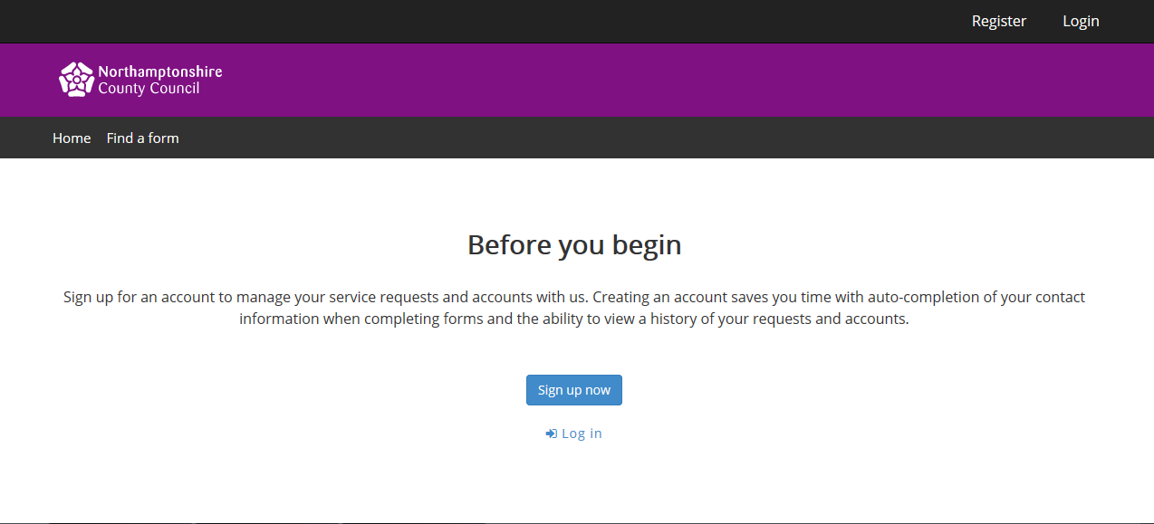
Click the ‘sign up now’ button.
Step 1 - Register
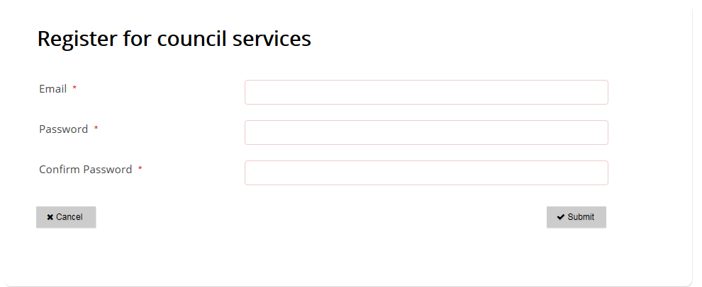Enter an email address for you or your organisation (this will be copied later in step 4 of the registration process)
This is the email address where email confirmation for your referrals will be sent.
Choose a password that meets the criteria
- at least 9 characters long
- contains at least one lower case letter
- contains at least one number
- Click the submit button

Step 2 – Provide Referrer’s details
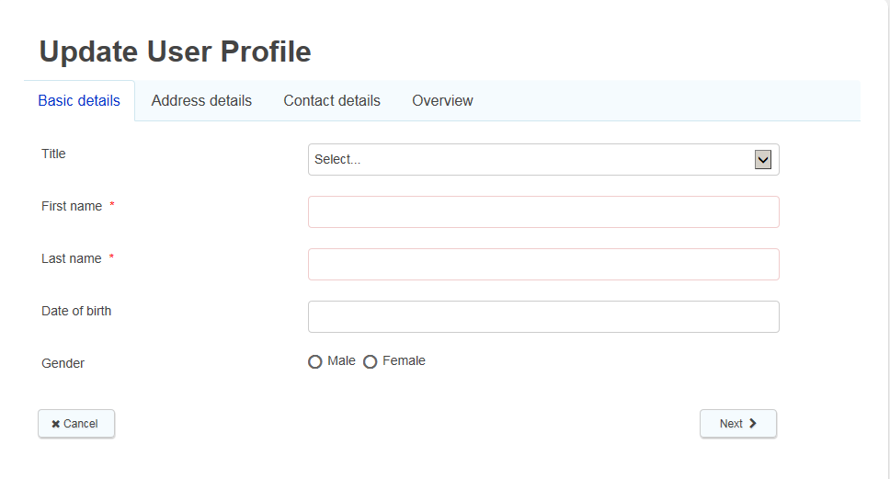
Enter the first name and last name of the referrer. The fields for title, date of birth and gender are not mandatory. Click next.

Step 3 – Provide Referrer’s address details

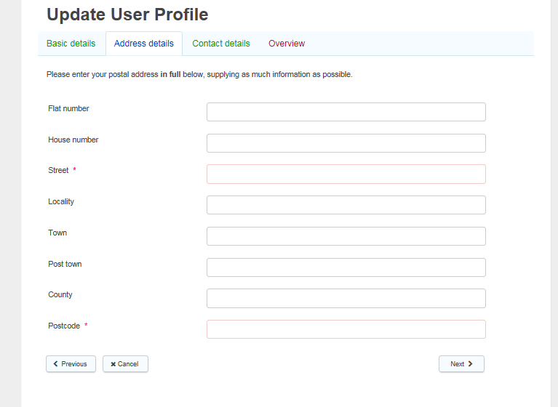
Enter the address for your company or agency. Only fields with an asterisks* are mandatory.

Step 4 – Provide Referrer’s contact telephone number

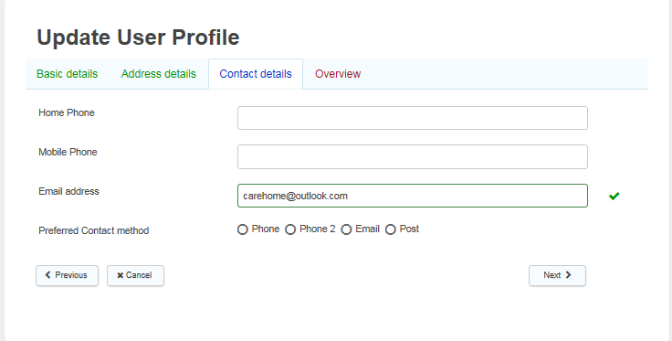

Enter your main contact telephone number where is asks for Home Phone, and select email as preferred method of contact. There is no need to provide a mobile phone contact. Click next

